1: write a query to display department_name,no_of_employees departments having 20 or more employees

SELECT DEPARTMENT_NAME,COUNT(EMPLOYEE_ID) AS NO_OF_EMPLOYEES

FROM DEPARTMENTS,EMPLOYEES

WHERE DEPARTMENTS.DEPARTMENT_ID = EMPLOYEES.DEPARTMENT_ID

GROUP BY DEPARTMENT_NAME

HAVING COUNT(EMPLOYEE_ID) >= 20;



2: write a query to display employee_id,first_name,last_name,salary from employees whose salary greater than average salary of the own departments

SELECT EMPLOYEE_ID,FIRST_NAME,LAST_NAME,SALARY FROM EMPLOYEES E1 WHERE SALARY>(SELECT AVG(SALARY) FROM EMPLOYEES E2

WHERE E1.DEPARTMENT_ID = E2.DEPARTMENT_ID

GROUP BY E1.DEPARTMENT_ID);



3: write a query to display employee_id,first_name,last_name,full_name,salary,new_salary(salary*10%),difference(new_salary-salary)

SELECT EMPLOYEE_ID,FIRST_NAME,LAST_NAME,FIRST_NAME||' '||LAST_NAME AS FULL_NAME,SALARY, ((SALARY)*0.1) AS NEW_SALARY,

(SALARY*0.1-(SALARY)) AS DIFFERENCE

FROM EMPLOYEES;

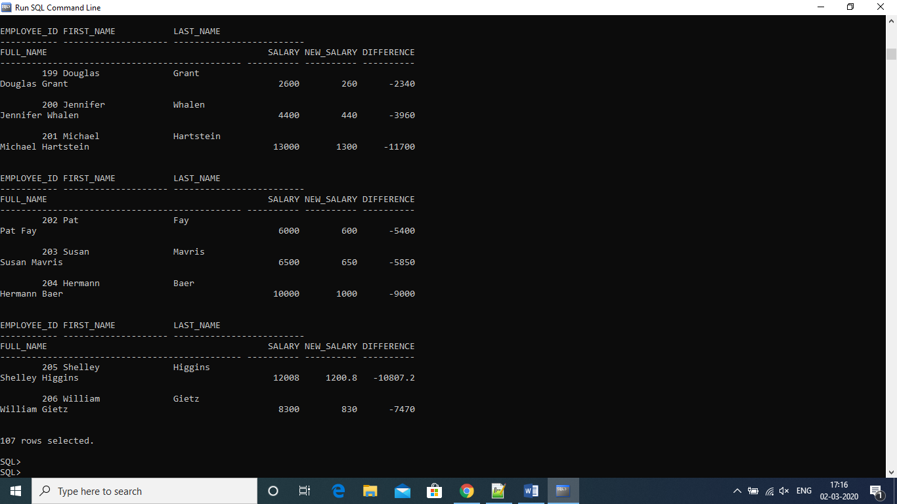

4: display employee_id,first_name,last_name,manager_first_name with president manager first_name is null

SELECT EMP.EMPLOYEE_ID,EMP.FIRST_NAME,EMP.LAST_NAME,EM.FIRST_NAME AS MANAGER_NAME

FROM EMPLOYEES

EMP LEFT OUTER JOIN EMPLOYEES EM

ON EMP.MANAGER_ID = EM.EMPLOYEE_ID

ORDER BY EMPLOYEE_ID;

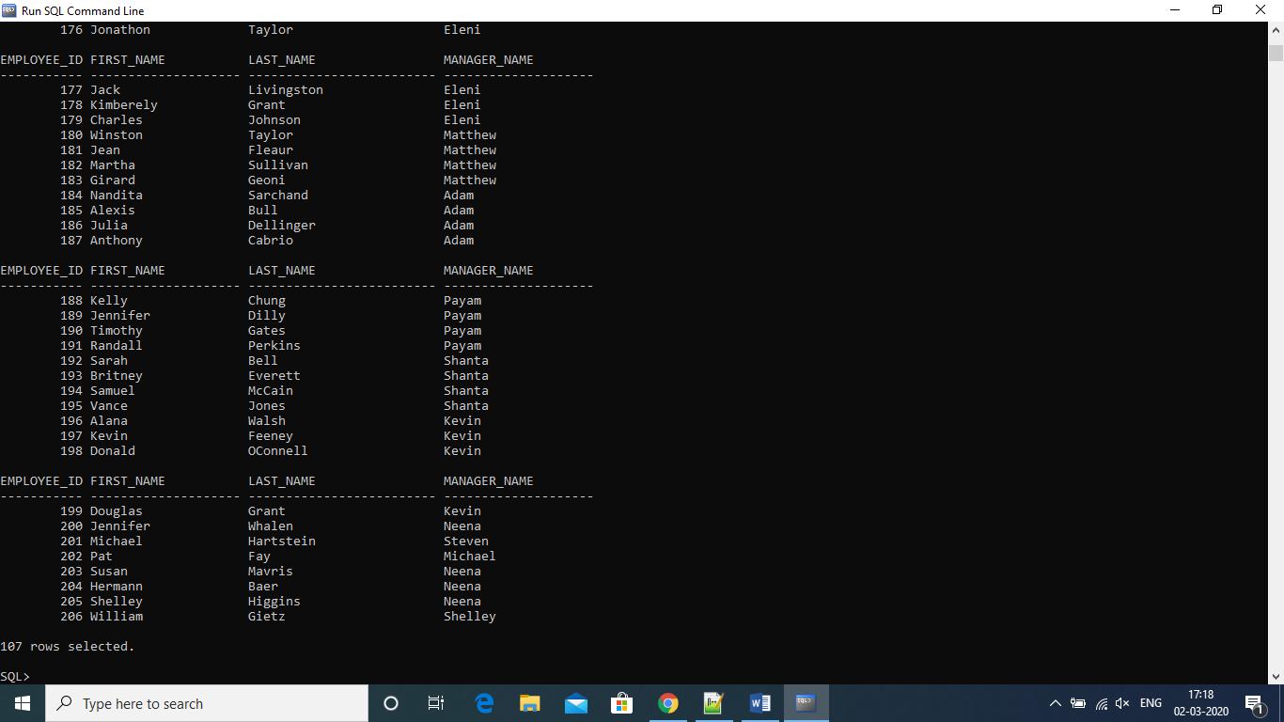

5.Display top 3 highest salary employees(employee_id,first_name,salary)

SELECT EMPLOYEE_ID,FIRST_NAME,SALARY

FROM EMPLOYEES

WHERE ROWNUM <= 3

ORDER BY SALARY DESC ;

